Discussion on Two Issues about the Next-Round Teaching Evaluation toward Colleges and Universities
 | Li Zhiyi* | Scan to Download
*Professor, National Inspector, Former President of Shenyang University of Chemical Technology, Former Vice President of Dalian University of Technology, Chairman of the Professional Certification Expert Committee of China Mechanical Engineering Society
E-mail: lizy@dlut.edu.cn

From 2003 to 2008, China successfully carried out a round of assessment of the undergraduate teaching level of ordinary colleges and universities, which greatly strengthened the teaching work in colleges and universities. This round of evaluation has achieved remarkable results and is of great significance. Currently, the Ministry of Education is organizing forces to study and develop the next round of evaluation programs.
A basic question in the next round of evaluation is how to name. We believe that the “Undergraduate Teaching Evaluation” is more reasonable for two reasons: 1) “Teaching Assessment” is an international term that uses “teaching assessment” to facilitate international exchange and recognition; 2) “Teaching Evaluation” has been inherited from the previous round of evaluation, and it is customary for people to adopt the “teaching evaluation” to help evaluate the “brand” construction and form an evaluation culture.
Regarding the international versatility and domestic habits of the “teaching assessment”, we did a literature survey. The results of searching large foreign literature databases containing humanities and social sciences indicate that the term “Teaching Evaluation” is very general, but there are very few entries in the “Talent Training Evaluation” (Tab. 1).
In fact, the three concepts of “higher education”, “talent training” and “teaching” are clearly defined in the field of higher education. "Higher education" is the upper concept of "talent training", and "talent training" is the upper concept of "teaching". According to modern educational theory and practice, higher education has three major functions, namely, personnel training, scientific research and social services. "Personnel training" includes two aspects: "cultivating people" (in the narrow sense of moral education) and "cultivating talents" (in the narrow sense, intellectual education), in which "cultivation" is mainly achieved through "teaching". In fact, the above-mentioned "teaching evaluation" has similar meanings to the "talent training evaluation".
What kind of assessment method is used is another key point of the next round of assessment planning? Driven by the next round of evaluation, we expect to establish a fully functional quality assurance system with “closed loop” characteristics. That is, the deviation is found through the supervision function, the deviation is corrected by the regulation function, and the cause of these deviations is analyzed through the improved function analysis, and the system is improved. In other words, these three functions are end-to-end laps, which are the relationship between input and output (Fig. 1).
Establishing a comprehensive, full-featured, perfect and effective talent training quality assurance system is not a one-time thing. China's university management has not yet reached this level. To evaluate the quality assurance system for talent training, such as the quality management system certification according to ISO9000, the following links are required: First, the quality assurance model for talent training should be formulated. The school establishes a quality assurance system according to the quality assurance model, and the school establishes a quality assurance system. An external review of the quality assurance system can be carried out on the basis of a complete implementation and evaluation of its effectiveness.

Tab.1. Foreign literature on the use of the term "Teaching Evaluation" and "Talent Training Evaluation"  Phrases Results  JSTOR Database GITC Database  Teaching Evaluation 395 673  Cultivation Evaluation 0 0 | 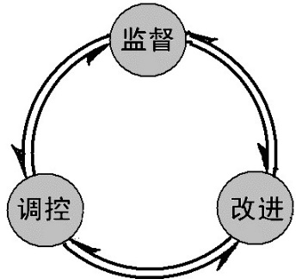
 | Fig. 1 A closed loop quality assurance system

